UNIVERSITY OF AVEIRO

DEPARTAMENTO DE ELETRÓNICA, TELECOMUNICAÇÕES E INFORMÁTICA

ENGENHARIA INFORMÁTICA

Portal de Self Service para Gestão de recursos virtuais do Campus


Authors:
Tomás Batista, 89296
Diogo Andrade, 89265
Flávia Figueiredo, 88887
João Dias, 89236

Mentors:
Prof. João Paulo Barraca
Prof. Cláudio Teixeira

June, 2020

Portal de Self Service para Gestão de recursos virtuais do Campus

Project Report on Informatics Engineering at the University of Aveiro, conducted by José Moreira, António Sousa Pereira, and Rui Aguiar, and oriented by João Paulo Barraca and Cláudio Teixeira (from STIC, Serviços de Tecnologias de informação e Comunicação) at the Department of Electronics, Telecommunications and Information Technology.

Keyword
- Management dashboard
- Switches
- Ports
- Vlans
- Campus Network
- Asynchronous

Acknowledgements
We are extremely grateful to João Paulo Barraca and Cláudio Teixeira for supervising and helping by giving us input throughout the development of this project.
We must also thank José Ramalho for the essential help and input given at a crucial time during the final stages of the development.
We also had the pleasure of working with the remaining members of STIC (Serviços de Tecnologias de informação e Comunicação), whom we very much appreciate for entrusting us with the responsibility to start the development of this new project.

Abstract
The Serviços de Tecnologias de informação e Comunicação, known as STIC, are responsible for the monitorization and management of the university’s network.
In order to perform tasks such as, amongst others, obtaining information about a certain device, they need to access it via terminal/shell with the use of bash commands. This creates a problem when a person who needs to perform one of those tasks doesn’t have the required knowledge or the time needed to do so. With that in mind, Self Service Campus was created.
To solve the referenced problems, the platform focuses on providing a user-friendly interface that allows for remote monitorization and management of the university’s network.
The final platform delivers a quick and easy way for the user to obtain information about any device belonging to the network. The information is displayed and accessible in different ways, since it takes into account the knowledge of the user and that may vary drastically. It offers a visual representation of the devices and an intuitive way of browsing through them and modifying them.

Contents (includes list of figures)
Keyword 4
Acknowledgements 5
Abstract 6
Contents (includes list of figures) 8
Introduction 13
Context 13
Motivation 13
Goals 14
Document Structure 14
State of the art 15
Related projects 15
SolarWinds 15
Fig. 1 - Dashboard from Solarwinds’ software 16
Kaseya 16
Fig.2 - Kaseya software environment 17
Technology 17
HTML, CSS and JS 17
D3JS 18
Frameworks: Bootstrap, JQuery and Ajax 18
Python and Django 19
Celery 20
Persistance: Postgres and Redis 21
Docker 21
Collaboration tools: Slack, Trello and Google Drive 21
Github 23
System requirements and architecture 24
System requirements 24
Functional requirements 24
User context description 24
Actors 24
Fig.3 - Use Cases Diagram 25
Use cases 26
Non Functional requirements 26
Assumptions and dependencies 27
System architecture 27
Domain model 27
Fig.4 - Domain Model 28
Physical model 29
Fig.5 - Physical Model 29
Technological Model 29
Fig.6 - Technological Model 30
Implementation 30
Web Application 30
Authentication 30
Dashboard 31
Fig.7.1 - Dashboard view 32
Fig.7.2 - Dashboard view (scrolled down) 32
Switches Rack 32
Fig.8 - Rack Diagram view 34
Ports Page 34
Fig.9.1 - List of ports from a certain switch 35
Fig.9.2 - List of ports to modify (enable or disable) 35
Switch Management 35
Fig.10.1 - Add switch view 36
Statistics 37
Fig.11 - Statistics’ view 37
Vlans 37
Fig.12 - VLANs’ view 38
Logs 38
Fig.13 - Logs’ History 39
Profile 39
Fig.14 - Profile 39
Worker 40
Communication with switches 40
Covid-19 Impact 41
Conclusion and future work 42
Summary 42
Main results 43
Future work 44
References 45

Abbreviations

SSC - Self-Service Campus;
DOM - Document Object Model;
UI - User Interface;
JS - Javascript;
HTTP - Hypertext Transfer Protocol;
XML - Extensible Markup Language;
MVT - Model-View-Template;
ORM - Object-Relational Mapping;
CRUD - Create Read Update Delete;
OS - Operating System;
RQ - Redis queue;
CI - Continuous Integration;
CD - Continuous Delivery;
ACID - Atomicity Consistency, Isolation, Durability;
IDP - Identity Provider;
API - Application Program Interface;
VM - Virtual Machine;
VLAN - Virtual Local Area Network;
REST - Representational State Transfer;
SSH - Secure Shell;

Introduction
Network monitoring is characterized by the use of a platform to constantly monitor a computer network. It can be extremely useful for spotting failing or slow elements on our network. This is closely related to network management, which focuses on the administration and management side of the network. The concept of being able to remotely monitor all the switches and respective ports of a university campus sounds advantageous and very convenient, so it was no surprise when STIC suggested that we created a platform that would do exactly that. Since it would be created from scratch, they would be able to sculpt it according to their needs and preferences, and get rid of features that they consider useless and that other pre-existing softwares have.
In Section 1.1 we mention the context and purpose of the project, which are then further explained in the following sections, 1.2 and 1.3. The details about the structure of the document as a whole can be found at length in section 1.4.

Context
This project was developed for the Informatics Project subject as part of the bachelor degree in Informatic Engineering. It was supervised by José Moreira, António Sousa Pereira, and Rui Aguiar, and oriented by João Paulo Barraca and Cláudio Teixeira. The purpose of the project was to develop a web application for a remote management of the university network to be used by the university’s Serviços de Tecnologias de Informação e Comunicação. It was developed in DETI/IT/remotely over the course of the second semester of the academic year of 2019/2020.

Motivation
Nowadays everybody uses the internet, and especially in a university that is known for its technological advancements, it has a very important role. However, almost everyone that uses it isn't aware of how to interact with the devices that are behind the internet being functional on campus. A professor might know that he wants an extra port here or there, but might not know how to do it, and even if he did and had the authority to do so, he would have to go directly to the device and apply the set up he desires via terminal/shell. Facing this, our objective is to come up with a solution to this problem by creating a web application that would easily allow for changes to be made remotely to these devices.

Goals
The main goal is to build a web application that allows the user to remotely check and manage the university’s network. The system should have a user-friendly display that allows even the less-knowledgeable user to be able to navigate through the website and check the details of a switch and/or a port. It should allow the user, depending on its permissions, to change the details of a switch, add a new one to the system, and other interactions. It will allow for changes to be tracked to a specific user and the respective device, so that possible errors are much easier to be tracked and solved.

Document Structure
The report follows the structure below:
In Section 2 is the state of the art, where we analyze similar projects and how they differentiate from ours. We also analyze the technologies used in the development of the project.
In Section 3, we analyze the system’s requirements and architecture.
In Section 4, we check how we came up with the solution to our initial problem, how it’s implemented and what it is trying to solve.
In Section 5 there is an analysis of the setbacks the current pandemic put on the project’s development.
In Section 6, we are going to analyze the whole completed work, analyze the results, gather some conclusions, and discuss future implementations.

State of the art
For the last couple of decades, the ability to make changes to several electronic devices is something that has been more and more predominant in our everyday lives. Living in a time where there is a possibility to monitor minor things from a distance, such as checking and making changes on our house’s temperature and/or lighting, we progressively realize how beneficial it is and, most importantly, that it would be very advantageous if it escalated into bigger projects. This concept is what our idea for this project originated from, as we believe that remotely manipulating and monitoring the campus network should be possible and, for practical reasons, fundamental.

Related projects
The following softwares provide the same basis as ours. The main difference between them and our software is that, unlike SSC, they don’t carry the additional features that are required to solve the problem. Besides, they don’t focus on the aspect of visual representation, which we also prioritize. Nonetheless, the main factor that led to the need for creating a new software was the budget. Monitorization software is not cheap, especially when it comes to the scale of a university. As a result of this, alternatives had to be thought of and constructed, thus the creation of SSC.

SolarWinds
Powerful network monitoring software that allows users to rapidly detect, diagnose and resolve network performance problems. It provides high-levels of network device and infrastructure performance, it is very flexible and customizable. The problem however is that it is a very expensive platform with recurring costs and if maintenance services are purchased.

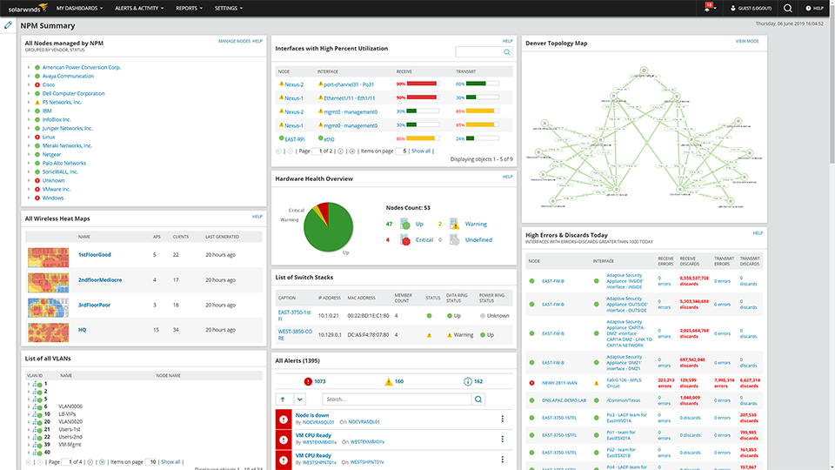
Fig. 1 - Dashboard from Solarwinds’ software

Kaseya
Cloud-based, management, it, remote monitoring and network security solution that can monitor all aspects of network-connected devices. It offers fast and stable remote access when there is a need to share a user’s session. This allows for a faster and efficient troubleshooting than to rely on a user’s description of a technical problem. Kaseya also offers great endpoint support and a customizable monetization system that suits the user’s needs. Despite all of this, it offers a very poor support system and customer service, lack of reporting tools, extra features like two-step authentication are very expensive and the UI can feel a bit dated.

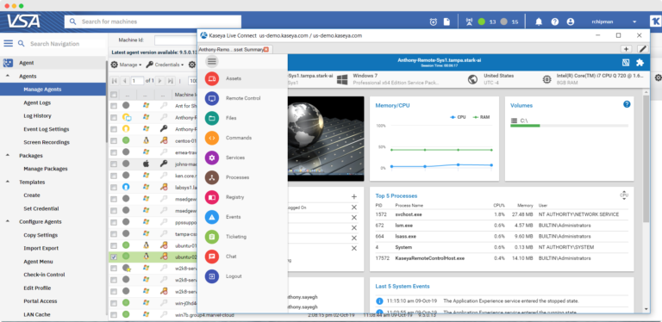
Fig.2 - Kaseya software environment

Technology
Brief explanation of the technologies used during development.

HTML, CSS and JS
Designed to be used by all web developers, and known as the code that describes web pages and provides the web page’s structure. It is the fifth release of the original markup language and by far the most used one. Even though there are many more options, the group had more experience working with HTML5, and its functionalities fit our objectives the best.
Cascading style sheets used to format the layout of web pages. It is designed to enable the separation of presentation and content including colors, layout and fonts. These factors can significantly improve the user’s experience and accessibility to a certain content of the website. Frameworks have a lot of limitations, so, even though we use them in our project, CSS helps us to fill in the gaps where the frameworks cannot do their job.
Javascript is an object oriented programming language designed with the objective of adding dynamic and interactive elements to a website, making the development of the website itself a much easier and attractive task. It provides tools for an enhanced user experience by allowing the developers to easily create animations, interactive maps and menus. There are many good options out there that we could have chosen from, but Javascript is a language that the team’s front-end developers have experience with and a solid understanding of. Given that it is a very powerful tool, which is supported by every browser and has a wide range of features, it was an easy choice for us. It also has a lot of scripts, plugins and libraries available online that make the development process an easier and more productive assignment. One of which is D3.JS, a JS library that we are going to further deepen in the essay.

D3JS
D3JS is a Javascript library for visualizing data using web standards such as HTML, SVG and CSS. D3 is by far the most popular JS data visualization library that exists. It is very lightweight and does not provide or focus on any set feature, giving the developer full control of what he wishes to build. This is a particularity that a lot of the other options fail to achieve, for example, libraries like Chart.js or Tree.js are very good, but only on their specific fields. In our project, a lot of visualization needed to be made using Javascript, and D3 was the only one able to fulfill all our needs. Although simple visualization components, like tables, would be easily made with a library like Chart.js, it lacked the freedom that D3 provided, as well as the power and toolset needed for some of the most complex visualization tasks such as the map and the switch racks.

Frameworks: Bootstrap, JQuery and Ajax
Bootstrap is a framework that allows to design websites in a faster and easier way. It is a powerful toolkit that contains a collection of HTML, CSS and Javascript tools for building web page interfaces. It comes with predefined terms, making it easier to create certain interface components without having to start from scratch. With Bootstrap, details such as the page width and length are not a problem, saving us a lot of time in tweaking and perfecting the looks of the application. It certainly has its restrictions, but when used in combination with CSS, they match perfectly. Our front-end developers already have a lot of experience with this framework, and given all its benefits, it was a quick and easy choice to make when it came to picking our tools.
JQuery is a lightweight Javascript library that facilitates the use of JavaScript on a website and simplifies the DOM and event handling manipulation. Not only is this library extremely lightweight, but also much more optimized than ‘regular’ JS. It simplifies a lot of functions that Vanilla Javascript also has, saving a lot of time in the developing process and making our platform load faster. Most of the benefits that JQuery has are a finer version of the ones JS already offers. It also simplifies the use of AJAX, which we used for the communication and fetching of information. We will look further into it in the next sub-topic.
Asynchronous Javascript and XML. It is a technique for better, faster and more interactive websites. In other words, it is the use of an XML HTTP Request object to communicate with servers. It is able to send and receive information from a server in an asynchronous way, meaning that the page does not need to be refreshed in order for the values on the screen to update. This is perhaps its most significant feature, especially when it comes to our project. Since our system focuses a lot on fetching and displaying updated information, being able to do it without refreshing the page, in an asynchronous way, is a key feature. Additionally, by only fetching the information required, we get a faster interface experience and response time in return.

Python and Django
Python is a general-purpose coding language. It is used in software applications, and it can also be implemented as a scripting language for web applications. Due to its simplicity, it is one of the most used programming languages. This straightforwardness and easy-to-read characteristic makes it a solid language to work with in a team setting, as it is much more readable than most languages. Due to its high demand and popularity, it has a vast amount of resources and libraries, making the development of certain features much faster and efficient. It has a lot of available and solid frameworks, from which we decided to pick Django. We will look further into this framework in the next sub-topic.
Django is an open-source high-level Python web framework that is used for rapid development and clean, pragmatic design. It follows a MVT architecture, making it practical and easy to understand, even for new users. Django uses a ORM layer that simplifies database manipulation. Essentially, this means that the user does not need to create tables and queries, as there is simply a need to write the table definition in python code, and it then takes care of translating it into the chosen query language. The developer has a lot of freedom when working with Django, since it supports the majority of the database systems. It facilitates the use of CRUD operations as well, as it does not require the user to have knowledge about the complex syntax behind the database system chosen. Because it allows developers that might not have experience with the current database system syntax to make queries simply by using Python, it is very beneficial in a team setting. Django also offers template features that allow for reusable web page components, being especially beneficial when the interface is not using a web framework like React JS or Angular, which is the case in our project. Django is very scalable, and that is something we had to take into account from the beginning, due to the possibility of our project having to escalate into something bigger. All the advantages previously mentioned, along with the fact that every member has experience working with the framework, did not leave any doubts when it came to choosing our web framework.

Celery
Celery is an open-source task queue implementation for Python web applications, focused on real-time operation, and tasks can be executed asynchronously or synchronously. Celery can run part of the software’s tasks either on the same server as other ones, or in a different server, decreasing the performance load of the software system. It is extremely flexible, even with the OS it runs on. It also has better broker support than the other options available, the monitoring is very easy to set up, and it provides all the information needed. Due to these factors, we decided to pick Celery and not other job queues like RQ.

Persistance: Postgres and Redis
Postgres is a powerful open source object relational database system. It has transactions with ACID properties, updatable views, primary and foreign keys, stored procedures and triggers. Postgres provides a lot of index techniques such as Generalized Inverted Index and Search Tree. It is very flexible and supports several replication methods. It also supports distinct types of geographic data storage techniques, like Key-Value Store and DBLink.
Redis is an open source in-memory data structure store that implements a distributed, in-memory key-value database with optional durability. It offers a framework to build an in-memory application that is versatile and scalable. It offers data replication and makes it easy to implement a client. It also allows for large sets of data to be inserted into the cache very easily. One of its best features is that it can withstand failures and still provide uninterrupted service. Because of this, and our previous experience with the tool, we decided that it would be the right choice to use it.

Docker
Docker is a tool that provides the ability to create, deploy and run applications in a loosely isolated environment called container. Its isolation and security allow for many containers to be run simultaneously on a given host. It enables faster software delivery cycles by making it easy to put products into producing and, if necessary, go back to a previous version. A docker container encapsulates everything the application needs in order to run, meaning that any machine with docker installed is able to run the application, which is a must feature when working in a team environment. Adding to this, the containers are also lightweight, self-contained and portable.

Collaboration tools: Slack, Trello and Google Drive
Slack is a business communication platform that can help a team to work together seamlessly, making online collaboration as effective as face-to-face interaction. Slack allows the team to communicate in just one place, and/or it can also be separated with the use of channels. Users can be a part of several channels, meaning that it offers an easy distribution of the team members depending on what they are working on. For example, there is the possibility to have a channel for the interface with the front-end developers, another one for the deployment with the DevOps developers, etc. The platform also enables the integration of external services like Github, Google Drive, Trello, and many more. This is a major functionality that helps when it comes to quickly referencing a specific component of a service, and stops the issue of other members not noticing these service changes. These features, along with the fact that it can be used everywhere (as it is also available as a mobile application), were the reason why we chose this platform as our main communication hub. Even though the free version is more limited, the features it contains were more than enough to fulfill our needs.
Trello is a collaboration tool for project organization that uses Kanban-style board lists to plan out the project’s development process. Its incredible visualization of the tasks, and its highly adaptability, make it a great tool for developing projects that contain more than one member. The notification system is a very strong feature, as every move made on the system can be seen by all team elements and a notification on Slack is sent. This further emphasizes the easy communication aspect that Trello brings to the table, which is crucial for every team member to be aware of every modification that is made. It also allows Github integration, so each task can be associated with a specific branch where that feature is being developed. Other tools like Pivotal Tracker were considered, because it provides more information about team productivity and overall project analytics, but it lacks the freedom and simplicity offered by Trello.
Google Drive is a cloud-based storage and synchronization service that allows users to store photos, emails and many other sorts of files on their server. Besides the software the project intended to develop, a lot of other documents needed to be carried out, from powerpoint presentations, to writing this essay itself. A lot of files needed to be made in a synchronous way with all of the team members and saved and stored in a reliable place. Since Google Drive allows for third-party integrations, the use of other Google tools, such as Google Docs and Google Slides, was key for the perfect collaborative development environment.

Github
Github is a Git repository hosting web service for software development version control. It offers the source code management and distributed version control functions of Git, as well as a whole set of features, such as integrated code search, bug tracking, feature requests and many more. Github allowed us to create an organization with all the team members, and each component had a repository. Inside each repository, feature branches were created and linked with the Trello’s task it was associated with. Despite not having a CI/CD pipeline integrated, it does have quality control assurance in the repository using Codacy. During team meetings, where small tasks and features were developed, we used Github’s issues feature as a complementary tool to Trello. Trello focused more on the feature itself, whereas issues were used specifically for taking care of small details inside or related to a specific feature.

System requirements and architecture

System requirements
In this chapter we will talk about the requirements of our system and explain the architecture we designed. We will talk about functional and nonfunctional requirements, use cases. We will also present diagrams for a better understanding of the topics.

Functional requirements
- Graphic Representation of the network
- Display of information
- Interface alterations based on access permissions
- IDP Authentication (UA Authentication)
- Authorization level
- Log Register (History)
- Alteration of equipment data
- Equipment Mapping

User context description
The system is designed to be used by any professor and stic member whose goal may vary from just being able to check a switch’s port state to a major switch component change.

Actors
The target user for the web application is anyone inside the university ecosystem: students, professors and any type of academic staff. Although the website is available for use by every organ in the university, the knowledge and skill between users can vary a lot. In order for the less experienced users to be able to do simple tasks such as viewing a specific port in a particular classroom, one of our main purposes was to make our user interface as friendly as possible.
This was achieved by focusing our goal on the visualization aspect of the platform. Investing in adding virtual maps, visual representation of vlans and even switch racks.
Our aim was not only to develop a web application that allowed users with little to no knowledge in the area to be able to check and monitor the network in the campus, but also for experts in the department to be able to easily change components in the network with just a few clicks.
The main actors are described in the following list:
- Subject 1 - Professor José: Teacher or Researcher that belongs to the DETI’s staff
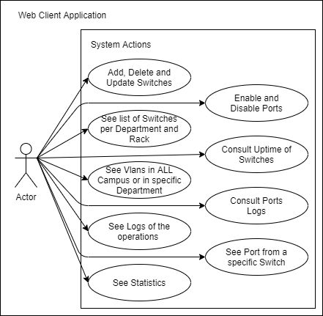
- Subject 2 - Stic Member Pedro: One of the working members of the Information and Communication Technologies Services (sTIC)

Fig.3 - Use Cases Diagram

Use cases
The user can in web site made many operations as:
- Add, remove and update switches.
  - Priority: High
- View the list of switches per department and inside of department per rack;
  - Priority: High
- View the logs of operations;
  - Priority: Medium
- View some statistics;
  - Priority: Low
- View vlans with range of all campus or per a specific department;
  - Priority: High
- View the ports of a switch and their status.
  - Priority: High
- Consult the port logs;
  - Priority: Medium
- Consult enable and disable the ports in switch;
  - Priority: High
- Consult the uptime of switches.
  - Priority: High

Non Functional requirements
- Intuitive: The software shall be self-explanatory
  - Priority: Medium
- Safety: Safety is the condition of a “steady state” of an organization or place doing what it is supposed to do.
  - Priority: High
- Performance: defines how fast a software system or its particular piece responds to certain users’ actions under certain workload.
  - Priority: Low
- Usability: Usability can be described as the capacity of a system to provide a condition for its users to perform the tasks safely, effectively, and efficiently while enjoying the experience.
  - Priority: Medium

Assumptions and dependencies
Our system is dependent on switches so they need to be working and on, it requires power and internet connection. The software is hosted on IT machines.

System architecture
In this section we will talk about what we used and what we implemented on our software showing some models with clear diagrams to better understand.

Domain model
The following diagram represents the relationship between these six classes, the Client, Web Platform, Backend, Database, Worker and the Switches.

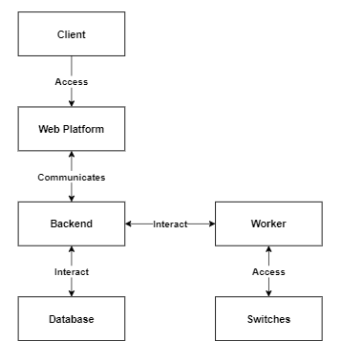
Fig.4 - Domain Model

The client consults information from all the switches and modifies them through our web platform. All of the client’s interaction with the equipment occurs in the web platform, applying a level of abstraction.
The web platform communicates with the Backend to get all the data and to commit the alterations.
The Backend interacts with the Worker, accessing its endpoints, requesting data from the switches and making changes to the ports and updating the actual information we have on cache on our database.
The Backend also interacts with the Database, which is responsible for saving the switches data.

Physical model
The next diagram represents essentially how our application will work. The app will be in a virtual machine hosted in UA, and it can be accessed by several clients. We will use Cisco APIs given by Stic and that will allow us to change UA’s network equipment.

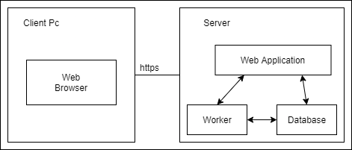
Fig.5 - Physical Model

Technological Model
This diagram represents the physical architecture of the system, as well as the technology we use in each layer. The diagram is grouped by devices that clients use to enjoy the app, devices that remain on the back-end, and devices used to host databases and APIs.
For the client layer, we developed a web app in JavaScrip and Jquery, making some requests with Ajax and using D3JS technology to make the graphics. That will communicate with relational databases, Postgres through Django REST API and are deployed with Docker, Gunicorn and Nginx. This layer also will communicate with another Django Application(Worker), that will run the operations in switches and send the data for the database.

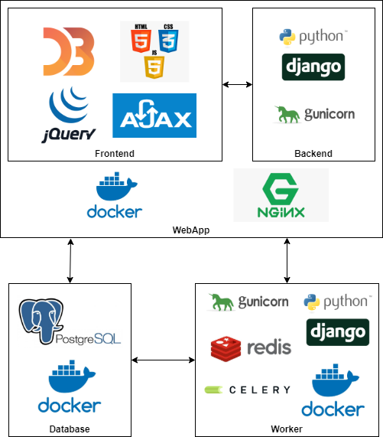
Fig.6 - Technological Model

Implementation

Web Application

Authentication
In our application the authentication system is currently implemented using Django Authentication System. However, our system is prepared to implement the IDP login of the university. Due to a lack of time and the need to implement more features, it was not possible to finish. Still, our application is prepared to implement and integrate the IDP. We designed the database to receive the data of the users, configured the endpoints to call the login url of the university (but not being used) and the settings plus libraries are ready to start using, we only missed time.
With the current user system all the website is blocked to logged in users (so we can keep track of the logs). Non-logged users can only see the dashboard (map, departments and switches lists) but cannot interact.

Dashboard
At the home page of our web application, the user is greeted with a table that contains all the switches along with the respective department they are associated with. When one of them is clicked, the user is redirected to the Switch Racks page, which contains the switch racks that the associated department accommodates. To the right of the racks, information of the selected switch is displayed on a table.
We are going to analyze that section in the next sub-chapter. Scrolling down on our webpage, we have a map and another table. The map is a visual overview of the campus, so in it we can see all the departments and easily move around and zoom in on a specific region. When we hover over a department, a name tag is shown, and clicking on it sends us to the Switch Racks page. The other table contains the department list, which allows the user to do a direct search, in case he already knows which department he wants to access, so he can just click on it and it redirects to the Switch Racks page. On the left side of the screen, there is a sidebar that allows the user to check other pages, more specifically, the user Dashboard, Manage Switches, Vlans, Logs and Statistics pages.

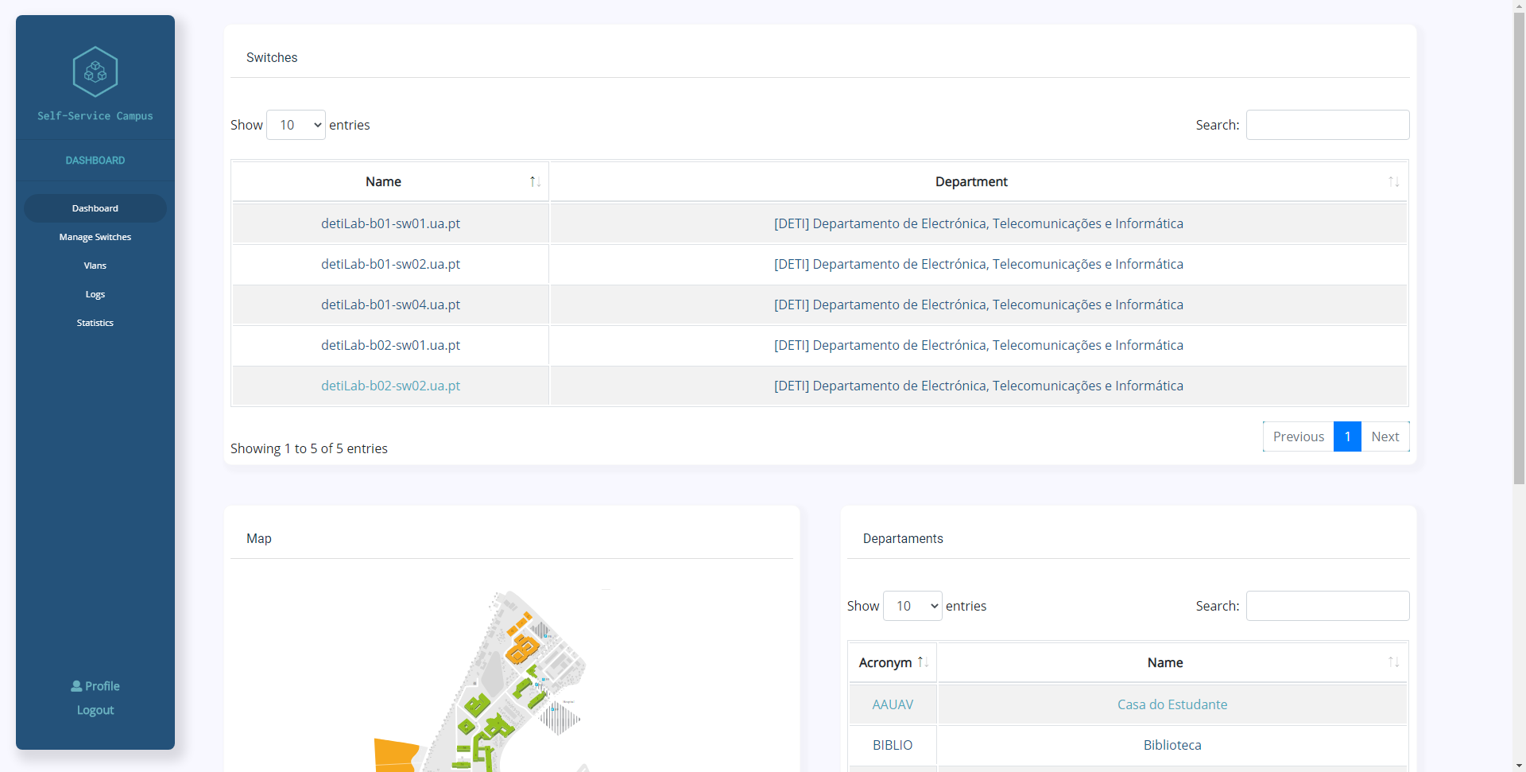
Fig.7.1 - Dashboard view

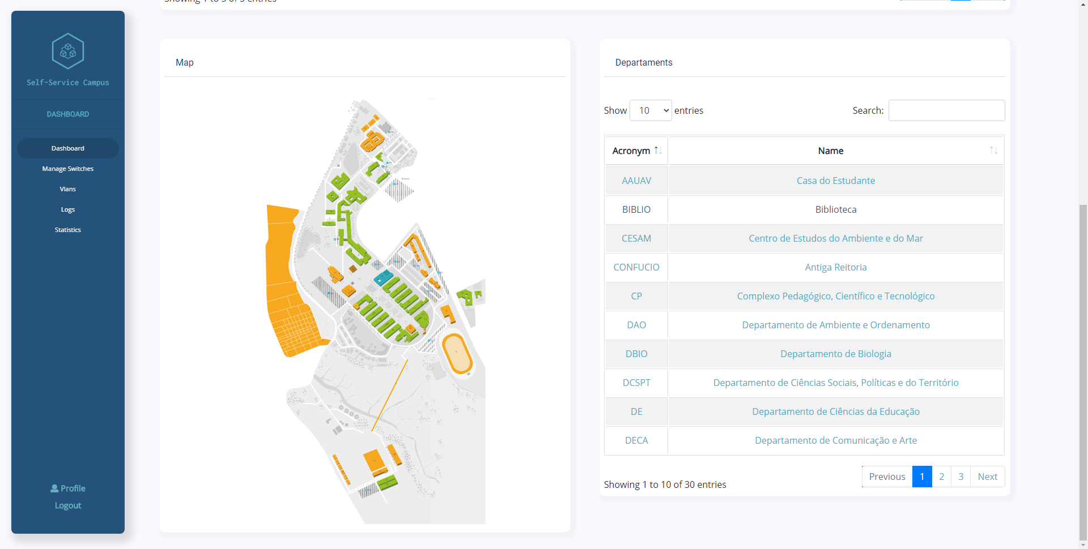
Fig.7.2 - Dashboard view (scrolled down)

Switches Rack
As mentioned before, there are several ways the user can access this page. When on it, the user is faced with a virtual image of the racks containing the specific department switches. To the right, a box is displayed, containing a table with information about the selected switch, which was picked in a previous page. It shows the department, hardware, hostname, IP and the timestamp of the last modification on our database.
Below the table there are two buttons, "Port" that will redirect the user to the Port page, and "Refresh Data" that is used to guarantee that the information on display is updated, since the page shows the values cashed from the last time that a refresh was made by a user and, in the meantime, the application acquires new information. Below the previously-mentioned box, another one is displayed, which contains a button to consult uptime, and that will take a couple of seconds to be displayed after being clicked, because the request travels to the Worker and then comes back, asynchronously, showing the requested information, the uptime of the switch.
Going back to the racks, these have the respective switches inside of them, and each switch has a red or green color on its side. These colors represent whether or not the switch has gathered all the information it needs, as it might not have successfully connected to the switch (either because it’s down, doesn’t exist or it’s unreachable). If this happens, the color that shows is red; otherwise, it’s green, indicating that it is connected and all the needed information was collected.
When one of the switches is clicked on, the switch information of the table on the right is updated.

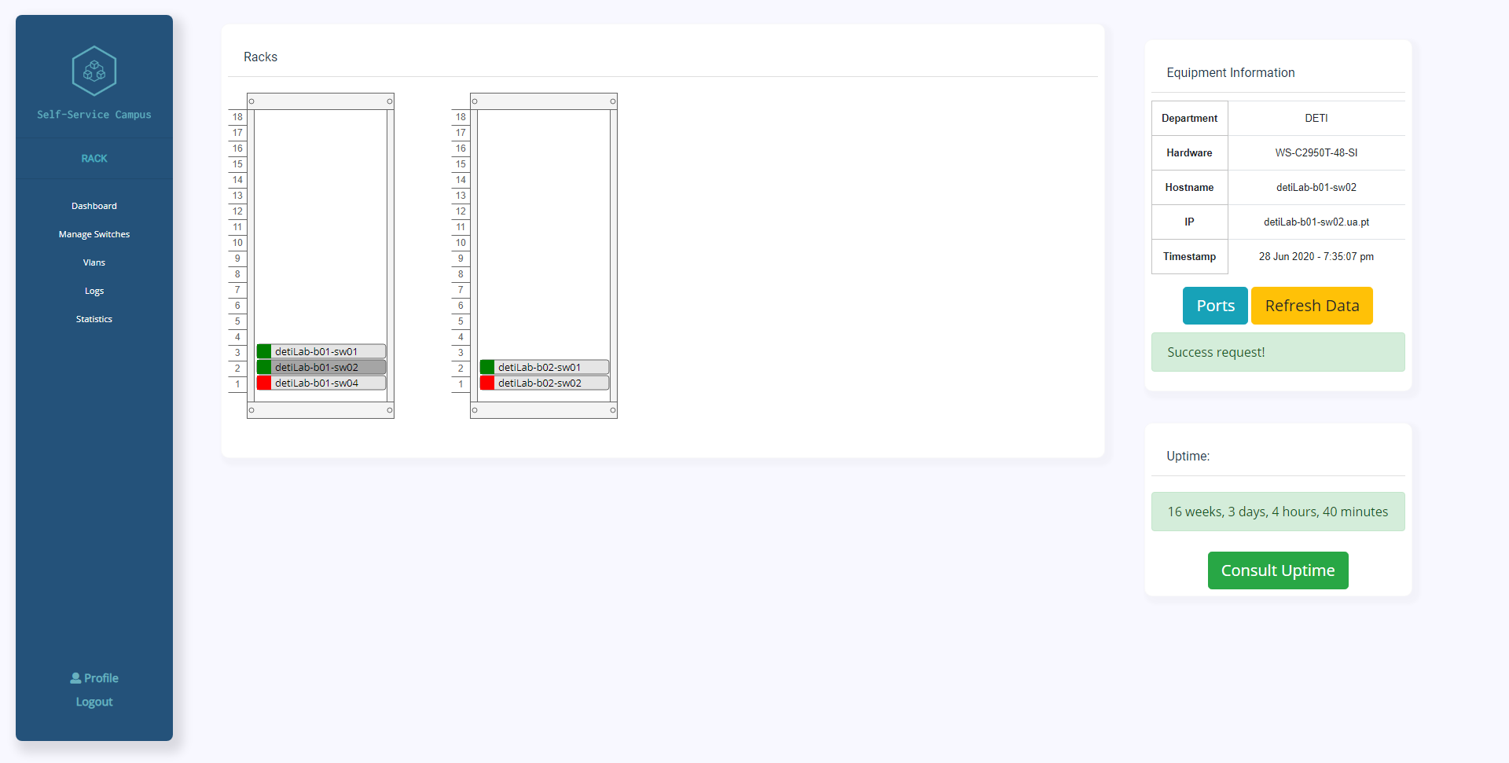
Fig.8 - Rack Diagram view

Ports Page
In the Ports page, all the ports information from the selected switch are displayed on a table. Each port has information about its interface, description, access vlan, native vlan, trunking vlans, duplex, speed, link status, protocol status, admin mode, mode, switch port and switch port negotiation. Just like in the previous tables, each port can be searched by one of its components. If one of the ports is selected, the user can scroll down and find a button to enable it administratively, or disable it. Above the buttons, all ports are displayed for a faster way to modify the desired port. Below that, it is also possible to consult the logs of the selected port(s).

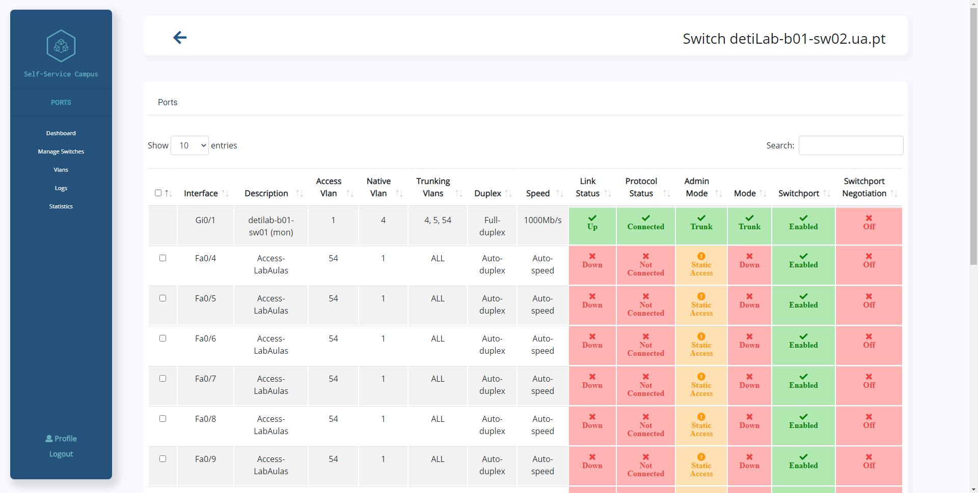
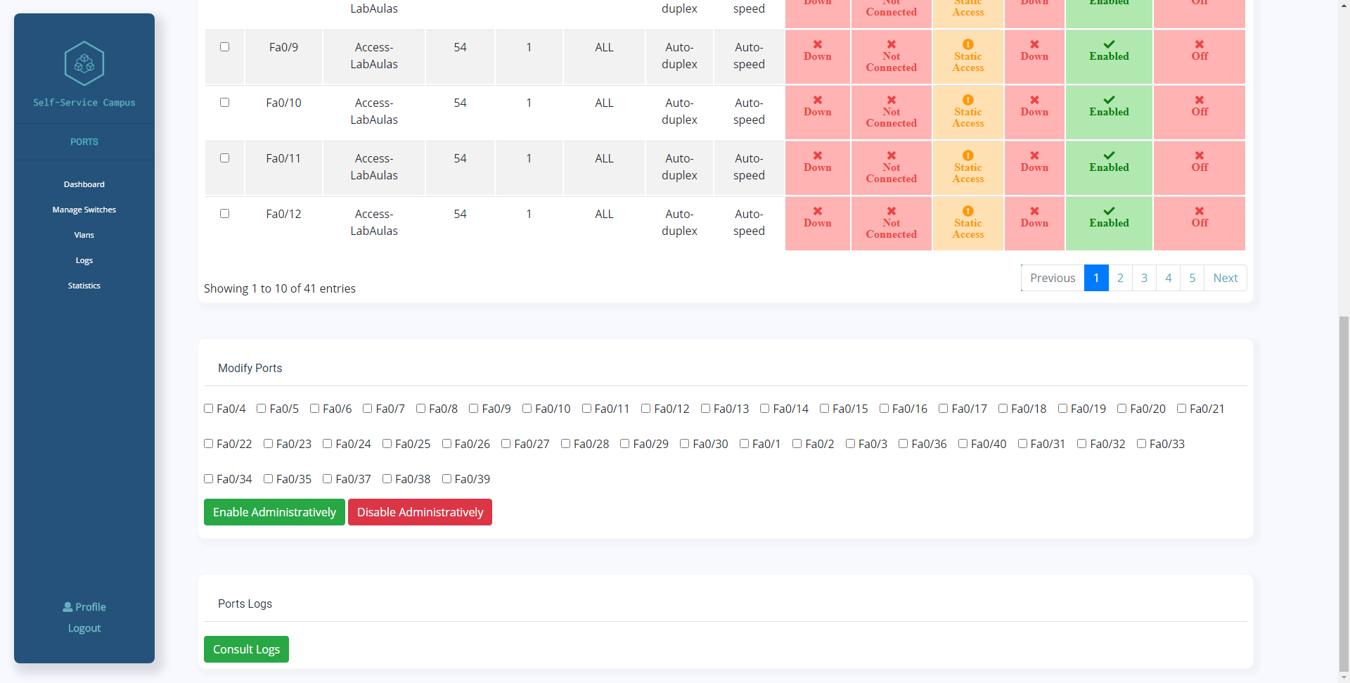
Fig.9.1 - List of ports from a certain switch

Fig.9.2 - List of ports to modify (enable or disable)

Switch Management
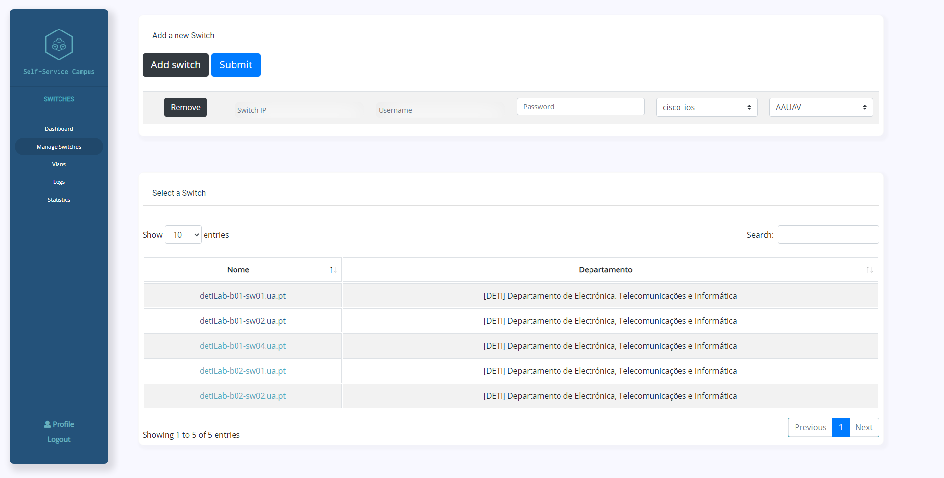
The Manage Switches page, that can be accessed through the side bar, is where users can manage and update switch’s information. At the top of the page, users have an option to add a switch, and when it is clicked, a small form appears asking for the switch ip, username, password, cisco type and department of the new switch. After all these fields are filled, the user can submit the new switch and a notification will appear warning the user about the outcome of that operation. Below that, there is a table with all of the switches. When one of those is selected, the user is sent to another page. This contains a form with all the details about the switch, and some of them can be edited, but others cannot. To do so, the user needs to click on the update button located at the bottom left of the form. The user also has the option to permanently delete a switch by clicking on the delete button at the far right of the update button.

Fig.10.1 - Add switch view
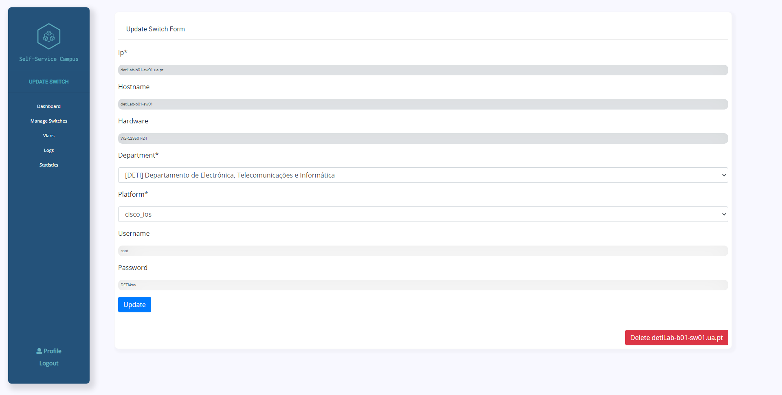Fig.10.2 - Update switch view

Statistics
Statistics play a big role in management systems, as it is what allows conclusions to be drawn from large sums of data changes. Despite this, at the time of writing, the only statistics available are the amount of switches in each department and the number of switches per hardware, both of these displayed within a graph. User statistics would be another one of our goals, but the IDP ua authentication would be required to do so, even though all the components for it to be integrated are already there, it’s not yet functional. Because of that, extra features involving the user cannot be done.
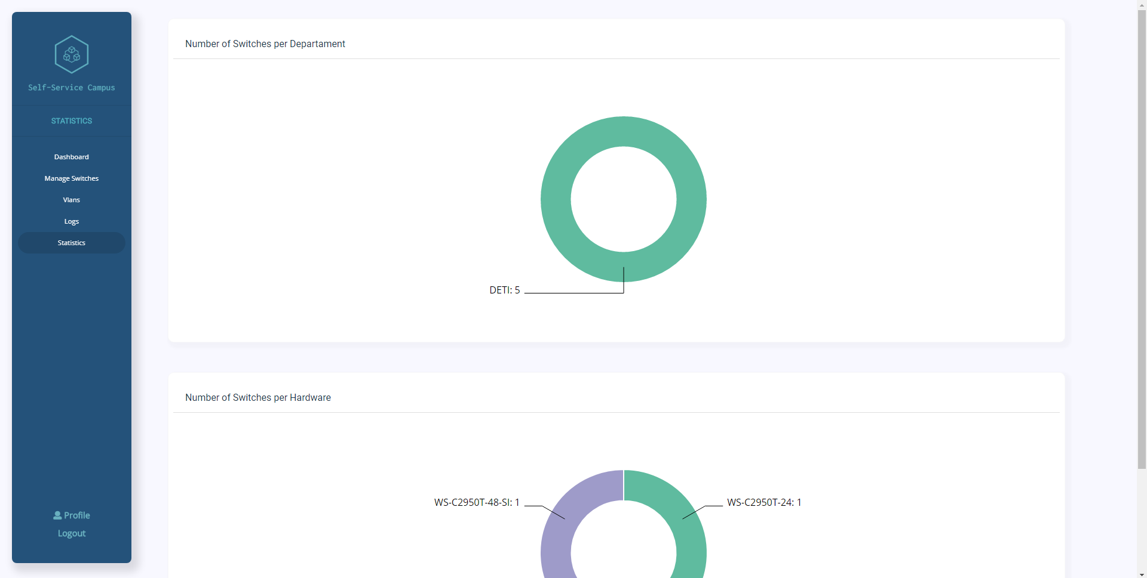

Fig.11 - Statistics’ view

Vlans
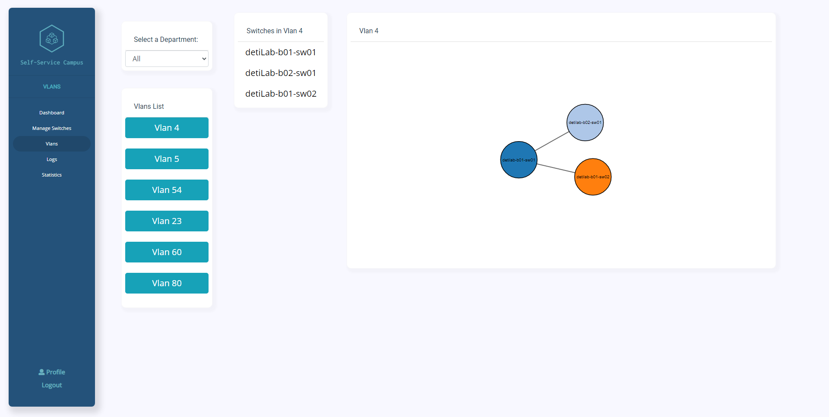
One of the main focuses of our project was to better represent informational data. This meant that we needed a better management and distribution of information, as we can see in the Manage Switches tab, as well as a better representational and visual stimulating way for the less experienced/knowledgeable users to be able to perform actions that they wouldn’t have been able to accomplish otherwise. Knowing this, and knowing that the concept of vlans isn’t an easy one to understand in a non-visual way, we created a vlans page where users can see every switch that is inside a vlan and how their connection is made with each other. The user is able to select a department, subsequent to that, a list of the vlans from the department is displayed on screen. Upon clicking one of the vlan buttons, the switches that belong to that specific vlan are displayed in a list and in a visual manner to the right, showing who is connected to whom.

Fig.12 - VLANs’ view

Logs
In the Logs page the user can see the log history. Every single action that was made to a switch is listed on a table. The user is able to see, for each log entry, who was the author of the modification, the action type (Add, Update, Consult uptime, ...), the respective switch that was altered, the date and the log id. The user can also search for a specific log entry through the above-mentioned elements. This allows for a quick way to check all the logs of a specific day or user, which is a great tool for troubleshooting. When we click on a switch in a log entry, the user is sent to a table containing all logs associated to that switch. Those logs are also searchable by every element of the table.

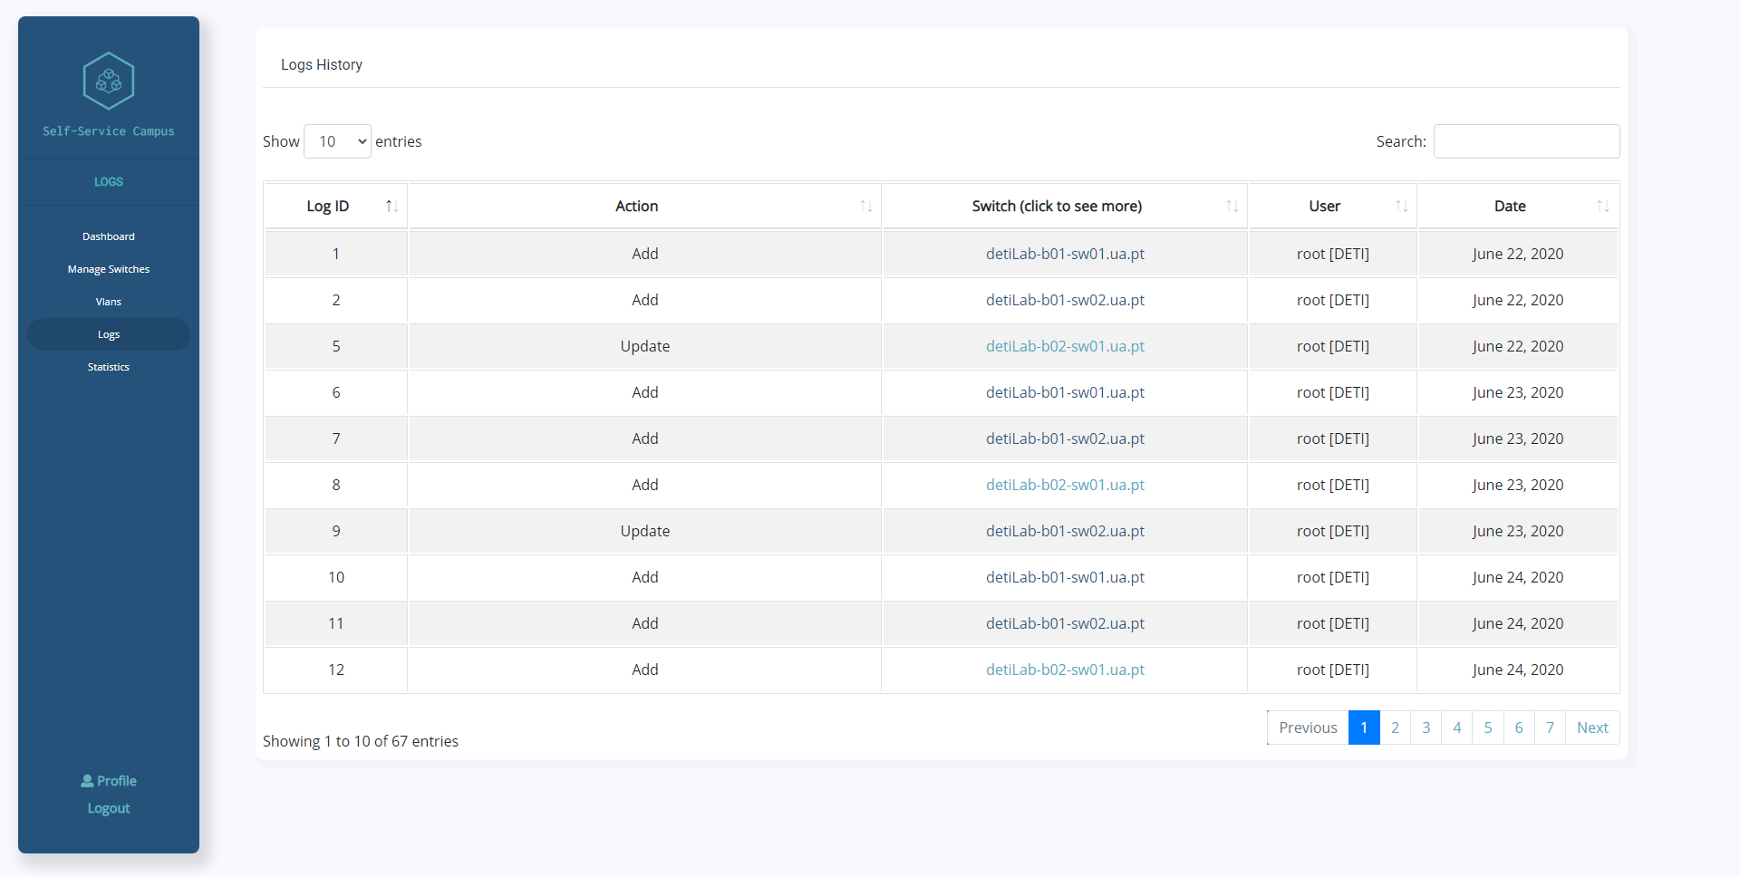
Fig.13 - Logs’ History

Profile
In the Profile page the user can scrutinize his own logs, just like in the Logs page, these can be filtered by each element of the table. The user can also logout of the platform by clicking on the Logout button located at the top right corner of the page.

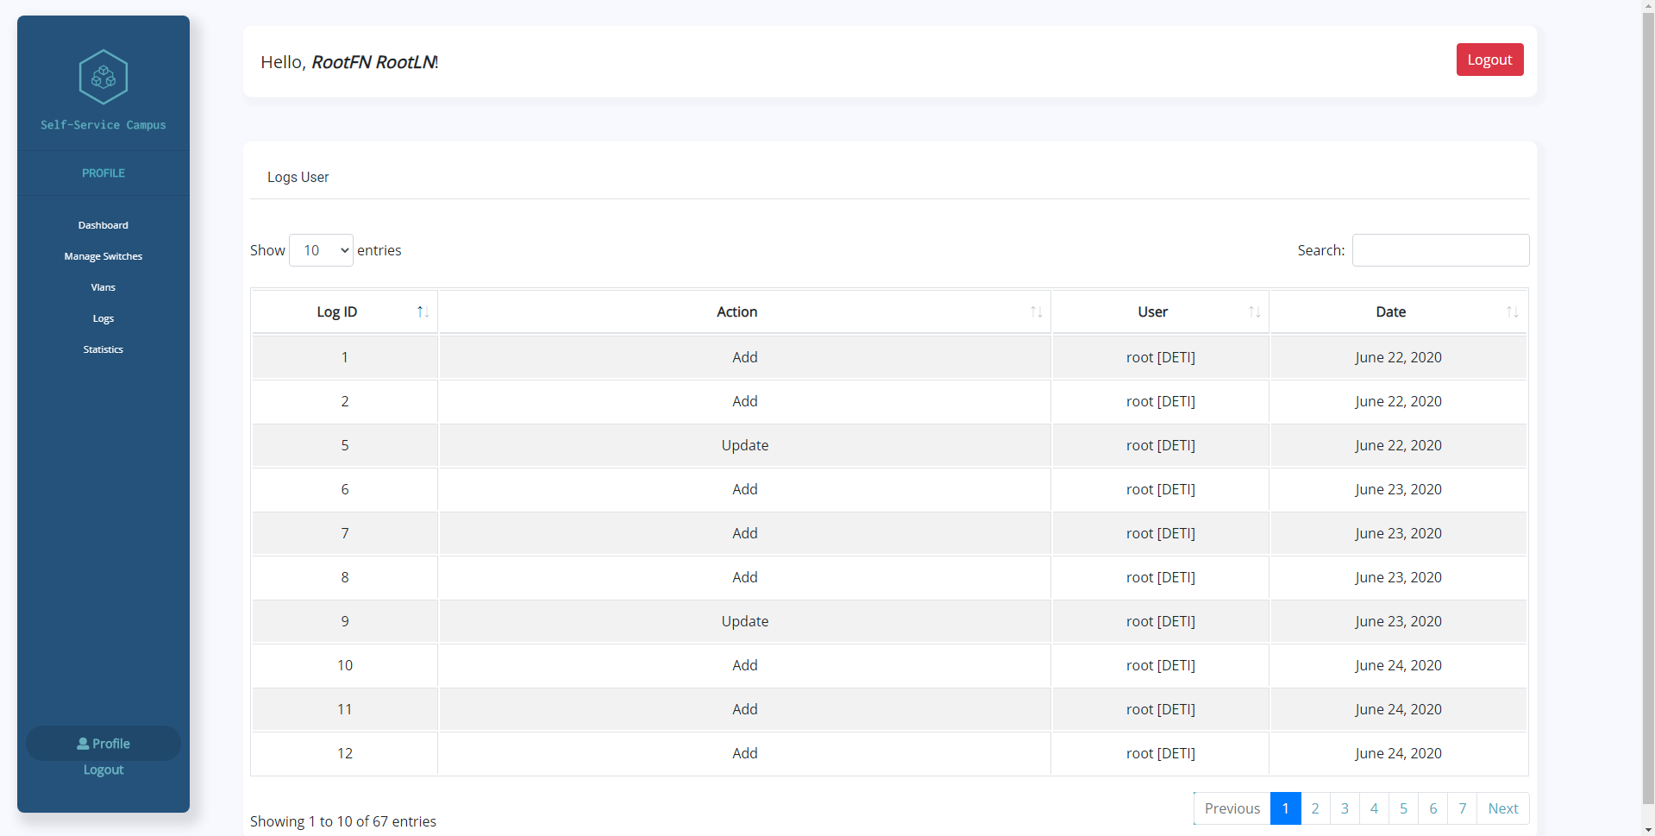
Fig.14 - Profile

Worker

Communication with switches
The worker is a Django application integration with Celery using Redis as message and queue, made by us to connect to switches. For this connection we create a class called SwitchConnector, this one responsible for the switch connections by ssh using the paramiko python library. In the case of a query, this uses another python library called ntc_templates to format the data.
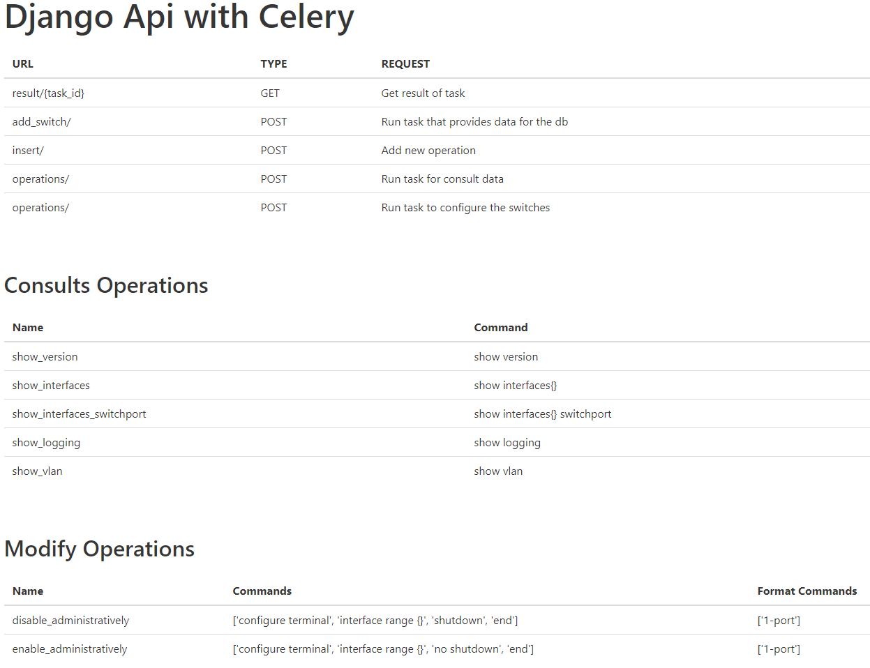
This has 4 endpoints, each one of them with its own purpose: one that fetches results from the tasks, another that fetches information from the switches and subsequently fills in the database, a third one to allow the user to insert new operations and, lastly, one to run operations.
Fig.15 - Worker endpoints

Covid-19 Impact
The coronavirus outbreak was very unfortunate and concerned everyone and everything. It affected our day to day lives, and especially the group’s ability to work dynamically, quickly and effectively. As we had never undergone something like this, we faced an utter need for adaptation, and new challenges that had to be overcome appeared, such as the communication not only between group members, but also with the supervisors. This may not sound like an issue at first, but internet connection problems, schedule misalignments, and the lack of access to certain resources whilst at home, were barriers that compromised the process.
Our main client, stic, was heavily affected and had new problems to solve as well. Our relationship with them was never ideal in the first place. Their busy schedule led to us having a low number of meetings, and them taking a long time to respond. One example of this is that it took them over a month to send us a testing zone for the switches and an api to retrieve that information, and when they did, it only contained three switches and information for us to use a simple txt. file as a replacement of an api. After the outbreak, the meetings were even more sparse, and the response time was still long, leaving us somewhat oblivious and unaware of the specificities we had to work on. We did not know whether we were implementing the features how they wanted them to be or not, or what sort of extra features they desired. The lack of feedback stalled our progress at times.
At the beginning of quarantine we were already behind on work, and it aggravated in the following months. We worked extra hard to overcome these new challenges, however, some of them were too damaging and made it impossible for us to implement some features that we had in mind. Despite all of this, the team did a good job working around this, going the extra mile to finish some of the desired features.

Conclusion and future work

Summary
This essay starts by explaining the context of the project, its purpose and objectives, and the problem it is trying to solve. Similar products are analyzed, particularly aspects such as the functionalities they offer, and the reasons why they are unable to fix the problem that the project at hand aims to solve. Because the final user of the product requested specific characteristics in the solution of the problem, the group reached the conclusion that those products were unable to fulfill all the needs. Subsequently, each technology used for the development of the project is specified, followed by a succinct explanation and description of its use, as well as the reason why that specific tool was picked over another similar one. Additionally, there is a chapter that contains the information related to the system’s architecture and requirements. It goes into detail about how the system is built and how the different parts of the software work together. In this section, a better view of the functionalities and uses of the platform can also be found, offering a clearer perspective of the use of the software. In the following section, there is a demonstration of the implementation, and the features and contents of the software are explained in detail. To conclude, the complications brought by the pandemic are briefly stated.
Overall we intended to create a platform that could allow every user (both experts and non-experts in this technologic field) to make alterations remotely to the devices present in the university network and to consult all the data from these. To do so, we created graphic diagrams of the devices’ display on the rack as well as a 3D representation of the University Campus making it easy for anyone using the platform to comprehend what they are doing.
Every interaction with the devices that were requested to be implemented, were completed with success, making it possible to make various types of alterations to the equipment remotely through our webapp.
The fact that this project required us to interact with physical equipment, that increased the complexity of our work a great deal.
The majority of the work that we developed is not visible to the naked eye, for example, we spent some time modulating classes to receive every type of switch, and even though that isn’t noticeable at first it is a key functionality.
Taking into account that the main theme of this work was not our field of expertise and many of the terminologies and information of it made everything a bit difficult to compute and develop, we managed to come up with a product that solves the problem presented by the sTIC members.
The product that we develop is ready to use although it misses some of the required features. This is not a major issue because everything is ready to be implemented, making it easy for our main client to adapt and finish the platform if that’s its intent. We created this project always aiming for its continuation in the future.

Main results
The initial goal of our project sounded very simple and straightforward: to make a clean and easy-to-use interface that allows users to remotely make changes to the university network. This idea was the foundation of the project, to which were then added a lot more features during the first stages of development and the requirements gathering phases. There was a big focus on the visualization part of the platform, and on the user permissions and log system. The system is able to do most of the originally desired features, for instance, we have the visualization focus with the addition of maps and other simplified interface components like the switch racks. These allow even the most inexperienced users to easily browse and look for the equipment they wish to find. The fetch and display of the switch’s information was also accomplished, and the user is able to not only check the switch and port details, but also change specific characteristics. The user does not have the IDP UA authentication, but is still able to log in and keep track of the logs and changes that are made.

Future work
There are two key features that we were unable to implement: IDP UA authentication and permission levels. From the beginning, we strived to achieve all the goals we had in mind for the project, but things didn't go as planned. These two features go hand in hand, since having permission levels requires the authentication to be implemented and fully functional, but due to several setbacks, they had to be shelved. Our objective was for authentication to be required in order for the user to be able to perform any sort of task in our platform, and to subsequently use the information received from the login to determine the user permissions. The user would then have restrictions to access certain features depending on the permission levels. The authentication would also allow for user logs to be saved and associated with the user, which would help, for instance, in the case of possible malfunctions in network configurations, as we would be able to easily know what the problem was, where it happened and who was responsible for it. Had we had the time, we would have implemented these features, as we believe they are a great asset and would improve our project.

References
[1] StackOverflow, https://stackoverflow.com/
[2] Real Python, https://realpython.com/
[3] Django Documentation, https://docs.djangoproject.com/en/3.0/
[4] Medium, https://medium.com/
[5] Gunicorn Documentation, https://docs.gunicorn.org/en/stable/index.html
[6] Docker Documentation, https://docs.docker.com/
[7] Youtube, https://www.youtube.com/
[8] Solarwinds, https://www.solarwinds.com/pt/
[9] Cisco Documentation, https://www.cisco.com/c/en/us/index.html
[10] Bootstrap Documentation, https://getbootstrap.com/
[11] W3Schools, https://www.w3schools.com/
[12] ITCentralStation, https://www.itcentralstation.com/
[13] Trustradius, https://www.trustradius.com/
[14] Kaseya, https://helpdesk.kaseya.com/hc/en-gb

